**PROJECT-1**

**SOLAR PANEL POWER OUTPUT SIMULATION**

**#Model PV panel under different irradiance and temperature**

**Inputs:solar irradiance,temperature,area,efficiency**

**Outputs:I-V and P-V characteristics**

**SOURCE CODE:**

**import numpy as np**

**solar_irradiance=np.array([100,1000])# w/m^2**

**temperature=np.array([25,30])# c**

**efficiency=np.array([0.8,0.9])**

**area=np.array([10,20])# m^2**

**power_output=solar_irradiance*temperature*efficiency*area**

**print(power_output)**

**import matplotlib.pyplot as plt**

**current=[2,4,6,8]**

**voltage=[12,14,16,18]**

**power=[10,20,30,40]**

**plt.plot(current,voltage,marker='s')**

**plt.xlabel('current(A)')**

**plt.ylabel('voltage(V)')**

**plt.title("voltage vs current curve")**

**plt.show()**

**plt.plot(power,voltage,marker='s')**

**plt.xlabel('power(w)')**

**plt.ylabel('voltage(V)')**

**plt.title("voltage vs power curve")**

**plt.show()**

**OUTPUT:**

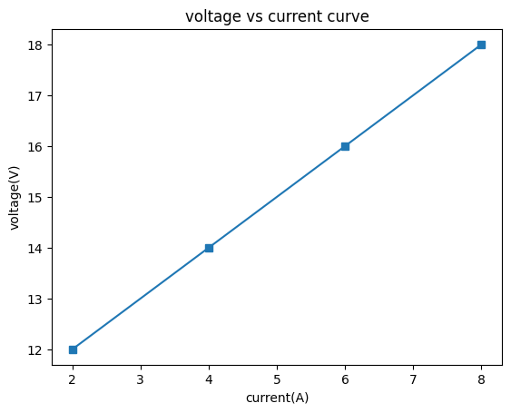

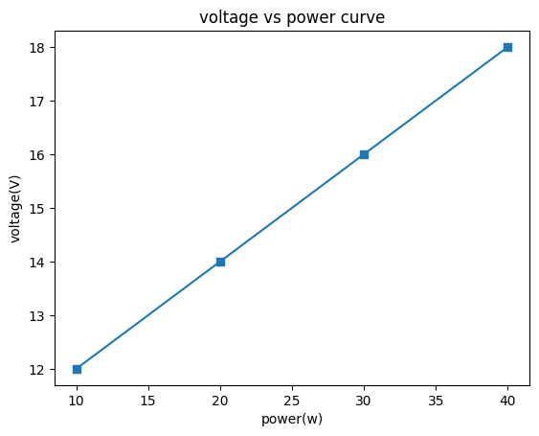

**[20000. 540000.]**

**CONCLUSION:**

**More sun (higher irradiance) boosts current and peak power, while higher temperature lowers voltage and efficiency—shifting the I–V and P–V curves accordingly.The PV panel model shows that solar irradiance mainly increases current and power output, while temperature rise decreases voltage and efficiency, together influencing the shape and position of the I–V and P–V characteristics.**